Lesson #1 and Lesson #9: Event Injection and Vulnerable Dependencies
Part 1) Goal and Vulnerability Summary
This part covers Lesson #1: Event Injection and Lesson #9: Vulnerable Dependencies. The main affected parts are API Gateway and the backend Lambda function. The security impact is remote code execution, which means attacker input can run code inside Lambda. The main weakness is unsafe deserialization and a vulnerable third-party package that treats user input like code instead of normal data.
Part 2) Why This Works / Root Cause
This attack works because the backend uses unsafe deserialization on attacker-controlled input. A vulnerable Node.js package accepts serialized functions, so the payload is treated like code and runs during deserialization. In short, the app trusts unsafe input, and an unsafe dependency helps the attack succeed.
Part 3) Environment and Setup
The test was done on my own DVSA deployment in a non-production AWS account in us-east-1. The API endpoint used was https://0bfhd583wc.execute-api.us-east-1.amazonaws.com/dvsa/order. The main AWS services used were API Gateway, Lambda, and CloudWatch Logs. The log group used for proof was /aws/lambda/DVSA-ORDER-MANAGER. The tools used were AWS Console, WSL terminal, and curl.
Part 4) Reproduction Steps
- Open the AWS Console and go to API Gateway.
- Find the DVSA API stage and copy the order endpoint:
https://0bfhd583wc.execute-api.us-east-1.amazonaws.com/dvsa/order
- Open CloudWatch Logs and make sure the log group /aws/lambda/DVSA-ORDER-MANAGER exists.
- Open the WSL terminal and set the API URL:
export API="https://0bfhd583wc.execute-api.us-east-1.amazonaws.com/dvsa/order"
- Send the crafted POST request:
curl -X POST "$API" \
-H "Content-Type: application/json" \
-d '{"action":"_$$ND_FUNC$$_function(){ var fs = require(\"fs\"); fs.writeFileSync(\"/tmp/pwned.txt\",\"You are reading the contents of my hacked file!\"); var fileData = fs.readFileSync(\"/tmp/pwned.txt\",\"utf-8\"); console.error(\"FILE READ SUCCESS: \" + fileData); }()","cart-id":""}'
- After sending the request, go back to CloudWatch Logs.
- Open the latest log stream in /aws/lambda/DVSA-ORDER-MANAGER.
- Check for the log message:
FILE READ SUCCESS: You are reading the contents of my hacked file!
Part 5) Evidence and Proof
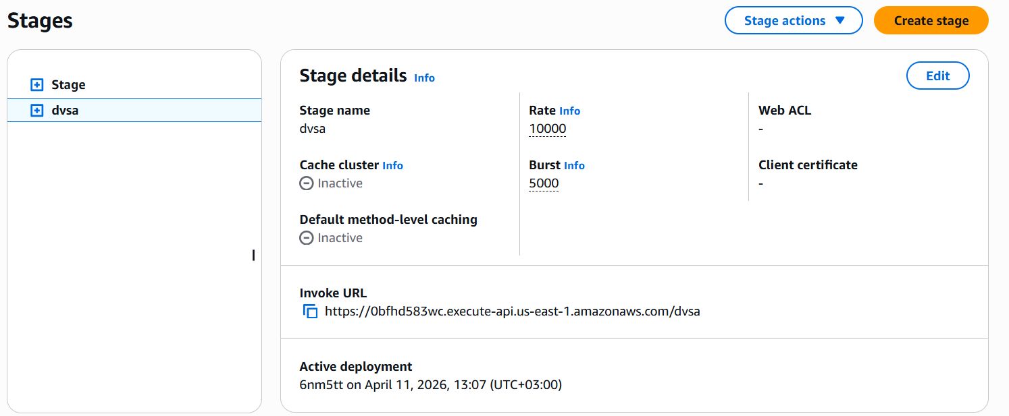
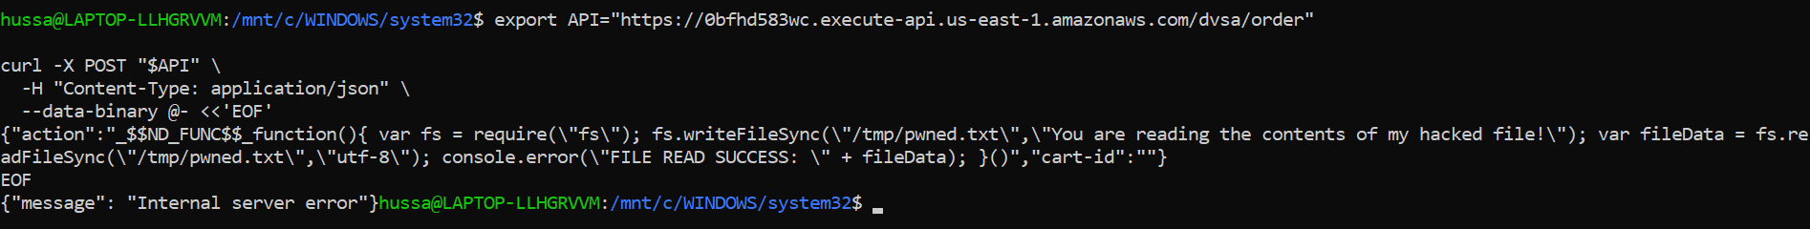
The vulnerability was confirmed by the CloudWatch log message FILE READ SUCCESS: You are reading the contents of my hacked file!. This shows that the injected JavaScript code executed inside the backend Lambda function. The payload wrote a file in /tmp, read it back, and printed its contents to the log. Even though the API returned an internal server error, the backend code had already run successfully. This proves the event injection issue and also shows the risk of the vulnerable dependency.
Part 6) Fix Strategy / Probable Mitigation
The fix belongs in the backend Lambda function that handles the order API request. The main security improvement is to remove unsafe deserialization from the request path, parse the body safely as JSON, and validate required input before processing it. This addresses the root cause because attacker input is no longer treated as executable code.
Part 7) Code / Config Changes
I changed the Lambda function DVSA-ORDER-MANAGER in order-manager.js. First, I replaced unsafe deserialization with safe parsing by changing serialize.unserialize(event.body) to JSON.parse(event.body || "{}") and serialize.unserialize(event.headers) to event.headers || {}. Then I added a check for a missing authorization header before splitting the token. If the header is missing, the function now returns {"status":"err","message":"Missing authorization header"} instead of continuing. This removed the unsafe logic that treated attacker input as code and added safer input handling.
Code before:
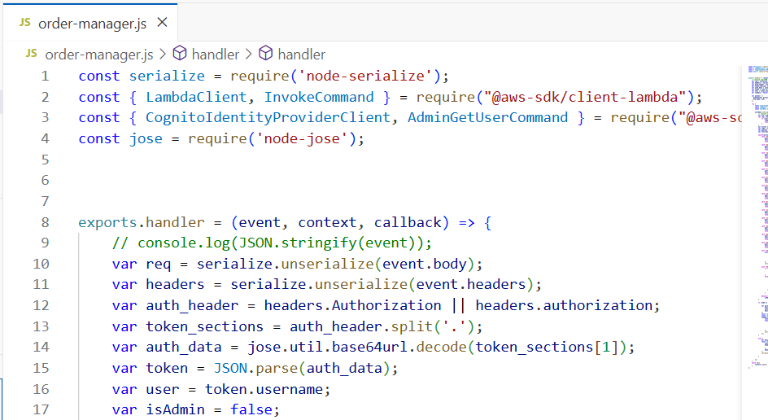
After:
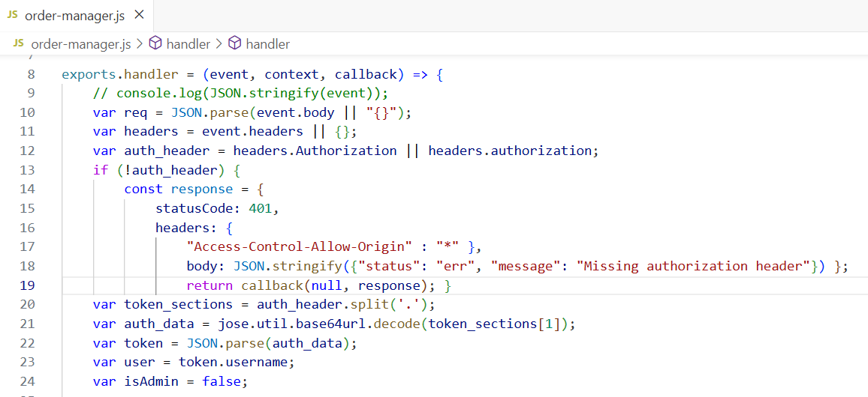

Part 8) Verification After Fix
After the fix, I ran the same crafted curl request again. This time, the API returned {"status":"err","message":"Missing authorization header"} instead of crashing. I then checked the newest CloudWatch log stream in /aws/lambda/DVSA-ORDER-MANAGER, and the message FILE READ SUCCESS: You are reading the contents of my hacked file! did not appear. This shows that the injected code no longer executed and the vulnerability was fixed.
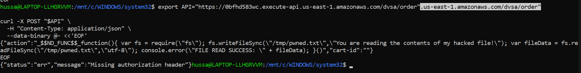
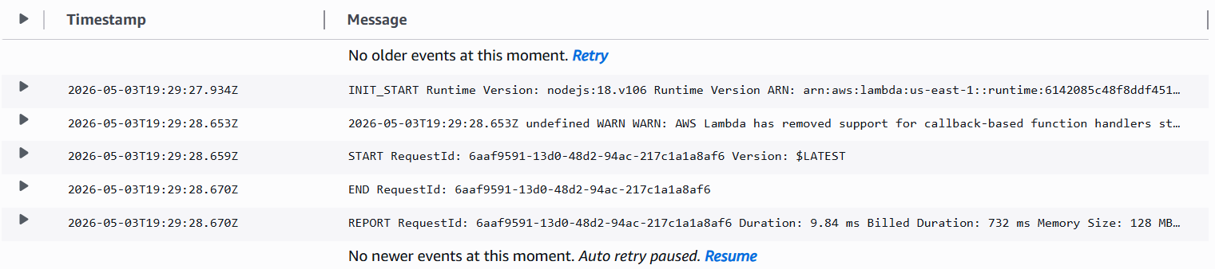
Part 9) Structured Operation and Security Analysis
Table 1: Structured analysis summary — Table A
Vulnerability | Intended Rule(s) | Artifacts Used to Infer Rule | Normal Behavior Evidence | Exploit Behavior Evidence
Lesson #1: Event Injection / Lesson #9: Vulnerable Dependencies | The order API must treat request body and headers as normal data only. User input must never be executed as code. | order-manager.js source code, API Gateway stage details, terminal output, CloudWatch logs | The intended flow is that API Gateway sends the request to DVSA-ORDER-MANAGER, which reads the request and processes only valid data fields. | The crafted request caused backend code execution, proven by the CloudWatch log message FILE READ SUCCESS: You are reading the contents of my hacked file!

Table 2: Structured analysis summary — Table B
Vulnerability | Why This Is a Deviation | Deviation Class | Fix Applied (Where) | Post-Fix Verification | Optional Latency Before / After Logging
Lesson #1: Event Injection / Lesson #9: Vulnerable Dependencies | The backend used unsafe deserialization, so attacker input was treated as code instead of data. This breaks the intended security rule of safe input handling. | Intentional misuse / security-relevant abuse | In DVSA-ORDER-MANAGER (order-manager.js), serialize.unserialize(event.body) was replaced with JSON.parse(event.body || "{}"); serialize.unserialize(event.headers) was replaced with event.headers || {}; and a missing authorization header check was added before token parsing. | After the fix, the same crafted request returned {"status":"err","message":"Missing authorization header"} and CloudWatch no longer showed FILE READ SUCCESS. | Not measured

Part 10) Takeaway / Lessons Learned
This lesson showed that the main problem was trusting unsafe input and an unsafe package in the backend Lambda. This is important in a serverless environment because even one vulnerable function can execute attacker input and affect other AWS resources. A safer design is to treat all user input as data only, validate it strictly, and avoid risky dependencies.

